We were taught PID as an undergraduate, but the problem is… we never actually used them.
In this video, I will be showing how I designed PID based self-balancing robot, breaking down what PID controllers is, its applications and why it’s important.
Same way people ask what calculus is for, saying ‘abeg we don’t even use this thing in real life.
Really…?? Really…??

Every smooth thing you enjoy today has calculus hiding inside it. Your phone’s touchscreen, camera autofocus, how your car brakes smoothly, how robots walk without behaving like drunk pigeons, how planes stay stable, how rockets don’t fall over, even how your AC keeps your room at the right temperature. All that is math doing the heavy lifting while we chop life.
PID is one of the ways that math shows up in real systems.
WHAT IS PID
PID stands for Proportional, Integral, and Derivative. It's a control system that helps machines or processes:
1. Get to a desired target (setpoint)
2. Stay at that target
3. Adjust quickly and smoothly
So PID basically helps a system stay on track.
If a system is not on track, that means there is an error, which can either +ve or -ve error.
The difference btw where the system is, and where it supposed to be is the ERROR
P - determines how fast the system responds to errors
I - determine how well the system removes steady-state errors
Steady-state error is like ‘when you are there, but not quite’
D - prevents overshooting and helps settle smoothly
All three work together to keep things stable. Think of PID like that one friend who keeps adjusting the AC so the room doesn’t get too hot or too cold.
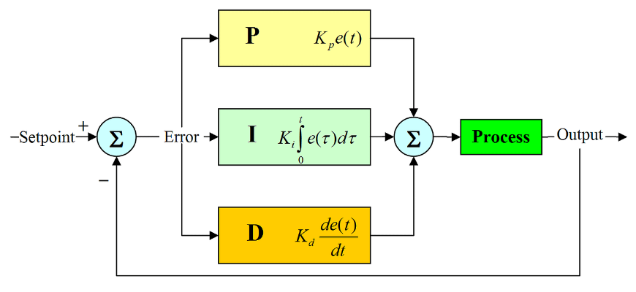

REAL LIFE EXAMPLES
“PID is everywhere. Drones staying level in the air. Cars keeping a steady speed. Robots balancing. Even your AC trying to keep your room at the right temperature.”

MY DIY SELF BALANCING ROBOT
“So I built a small self-balancing robot to test all this. It uses an Arduino RP2040 Connect, an L298N motor driver, DC motors, and acrylic for the frame.
I also added an HC-06 Bluetooth module so I can tune the PID values wirelessly, because nobody has time to keep plugging and unplugging wires every five seconds.”

“The robot tries to stay upright. When it tilts, the sensors pick it up, the PID calculates the correction, and the motors respond instantly. If the PID values are trash, the robot behaves like a drunk uncle. If the values are correct, it stands firm.”

WAYS TO GET PID VALUES
White Box
“You actually know the math behind the system. Equations, models, the full wahala. You use that to calculate the PID properly.”
Black Box
“You don’t know the math of the system. You just poke it, see what happens, and tune based on vibes and feedback.”
Ziegler-Nichols Method
“Set I and D to zero. Increase P until the thing starts oscillating like it’s possessed. That P is your ‘ultimate gain’. Measure the oscillation speed. Use that to calculate P, I, D.”
Trial and Error
“Honestly, the method most of us use. Adjust P until it responds well. Add I when there’s steady-state error. Add D when it’s overshooting. Keep tweaking until the system stops misbehaving.”

